Power Platform - Dataverse Tables Reading Steps
Azure-> App Registration-> New App -> Grant API Accesses -> Create Secret
Power Platform-> Add User-> Application user->Grant Access

Configuration
1. Azure + Dataverse Configuration (Step-by-step)
Step 1: Register an App in Azure (Entra ID)
- Go to Azure Portal → Microsoft Entra ID → App registrations
- Click New registration
- Provide:
  - Name: dataverse-reader-app
  - Supported account: Single tenant
- Click Register
👉 Capture:
- Application (Client) ID
- Directory (Tenant) ID
Step 2: Create Client Secret
- Go to Certificates & secrets
- Click New client secret
- Copy the value
Step 3: Add API Permissions
- Go to API Permissions
- Click Add a permission
- Select:
  - Dynamics CRM
- Add:
  - user_impersonation (delegated) OR application permission depending on use
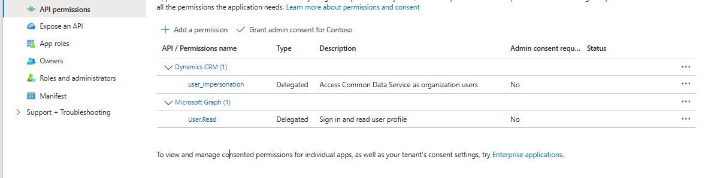
👉 OAuth is required for Dataverse Web API access
Step 4: Grant Admin Consent
Click Grant admin consent
Step 5: Create an “Application User” in Dataverse
This step is critical (many people miss this)
- Go to Power Platform Admin Center
- Open your environment:
- Go to:
  - Settings → Users → Application Users
https://admin.powerplatform.microsoft.com/manage/environments/< environment >/appusers
- Add new user:
  - Search and Select your Azure App
- Assign role:
  - Service reader
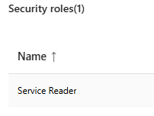
👉 Without this, you’ll get:
“user is not a member of the organization” (common issue)

Step 6: Identify Dataverse API URL
From power platform, go to your environment. Copy the url
https://<yourorg>.crm.dynamics.com/api/data/v9.2/
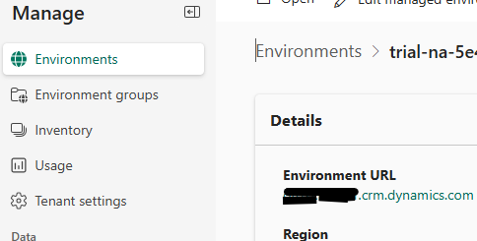
Example:
https://<org>.crm.dynamics.com/api/data/v9.2/conversationtranscripts
Review the following disclaimer and code as a sample for non-prod environments
anishkutti/dataversereader

